Week 2 Task: Advanced Data Visualization and Storytelling with Python
Comprehensive Weather Narrative for JFK Airport, New York
Dataset coverage: 2010-01-01 to 2018-07-27 | 114,544 hourly observations

1. Introduction
This report transforms a large historical weather dataset from John F. Kennedy International Airport into a visual story designed for non-technical readers. Rather than presenting raw tables, the analysis focuses on patterns people can immediately understand: seasonality, wet versus dry conditions, visibility risk, and wind behavior. Together, these views show how local weather shifts over time and why those shifts matter for airports, transportation planning, public safety, and climate-sensitive operations.
The analysis uses the cleaned NOAA-derived JFK weather dataset supplied for this assignment. The accompanying notebook indicates a prior data-cleaning workflow and confirms the dataset context: hourly airport weather observations with multiple atmospheric measurements. Notebook context summary: ## NOAA Weather Data Analysis - JFK Airport (New York) This notebook focuses on analyzing and forecasting weather patterns using the **NOAA Weather Dataset** collected from **JFK Airport in New York**. The dataset comprises **114,546 hourly observations** of **12 key climatological variables**, including temperature, wind speed, humidity, and pressure. This notebook teaches the user to extract, clean and analyze sample weather data and predict weather trends to help airports schedule better fli

2. Methods and Analytical Approach
The source file contains 114,544 timestamped observations from 2010 through mid-2018. Core variables include visibility, dry-bulb temperature, wet-bulb temperature, dew point, relative humidity, wind speed, pressure measurements, precipitation, and encoded wind direction. To support storytelling, the workflow converted timestamps into years, months, seasons, and daily aggregations. It also reconstructed wind direction in degrees using the sine and cosine encodings.
Visualization choices were made to match specific communication goals: line charts for seasonal rhythm, heatmaps for long-term structure, dual-axis summaries for annual wetness, density plots for relationships between atmospheric variables, distribution plots for comparing seasons, and a wind rose for directional behavior. Each figure is paired with an interpretation explaining why the chart type was selected and what a general audience should take away from it.
- Key design principle 1: Show trends before details so the audience sees the climate story first.
- Key design principle 2: Pair every visualization with plain-language interpretation rather than assuming chart literacy.
- Key design principle 3: Connect weather metrics to practical implications such as travel reliability, storm readiness, and operational planning.

3. Visual Analysis and Storytelling

Figure 1. Seasonal temperature cycle
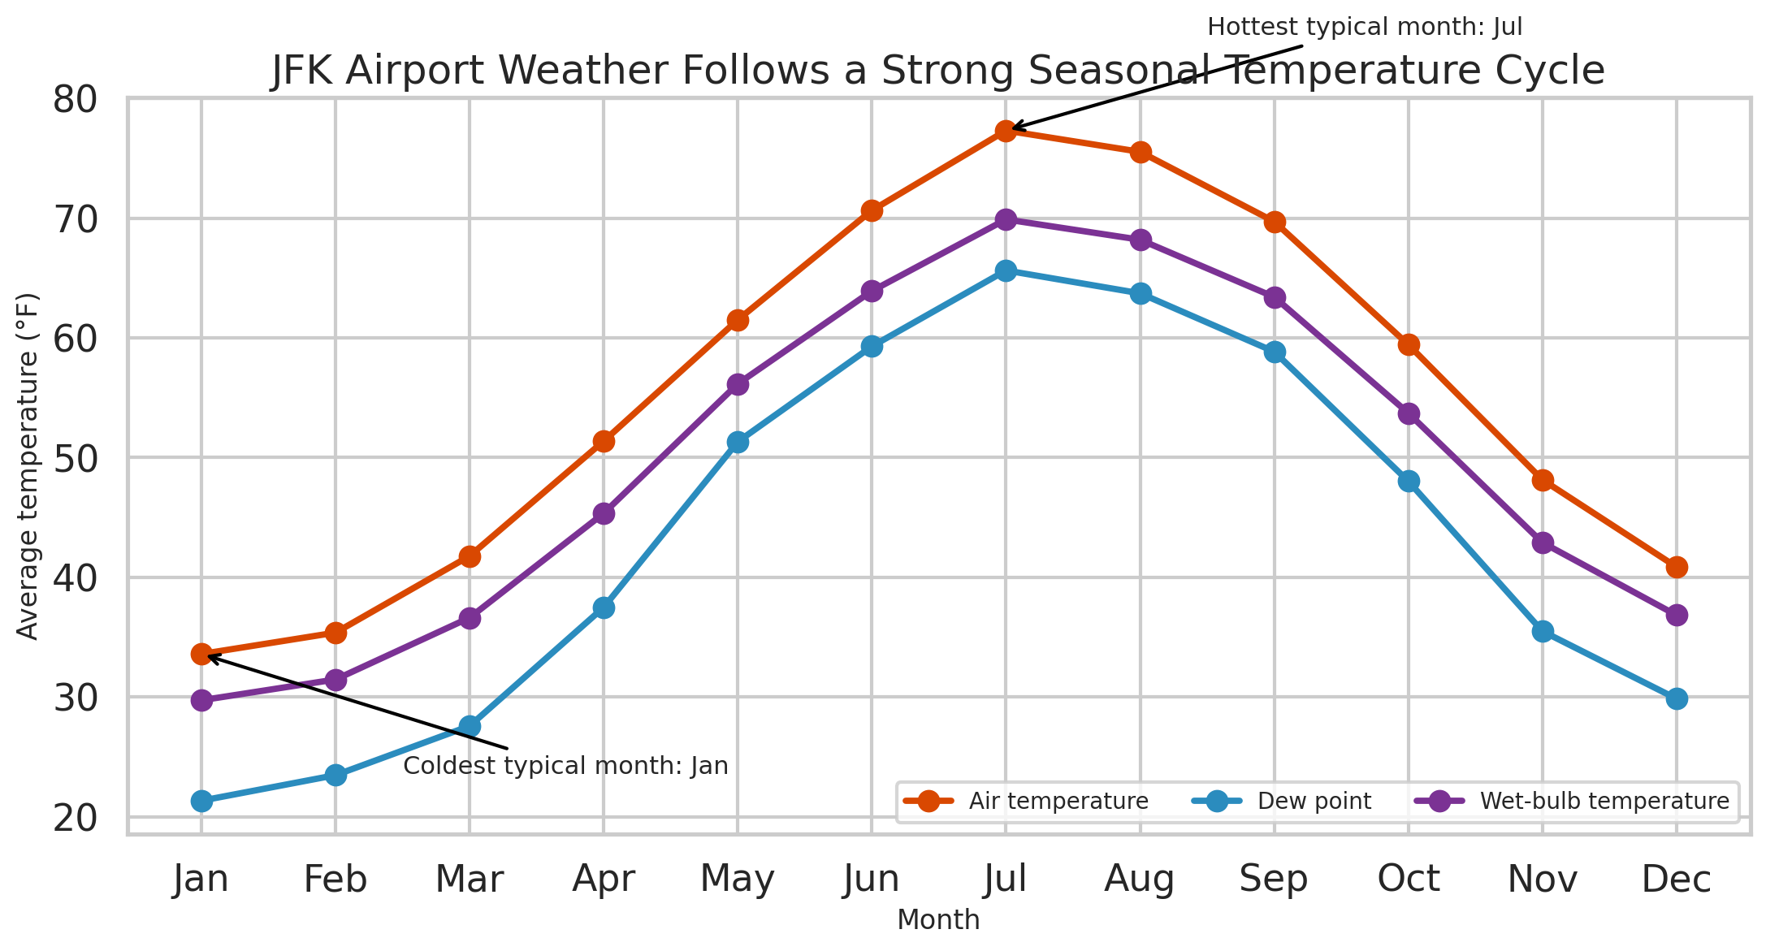
Average monthly dry-bulb, dew-point, and wet-bulb temperatures reveal a pronounced annual cycle, with the warmest typical conditions in summer and the coldest in winter.
A multi-line seasonal chart is the clearest way to introduce the dataset because it immediately shows cyclical behavior. Using three related temperature measures together helps the reader compare actual air warmth with atmospheric moisture content. This figure establishes the report's central narrative: JFK weather is highly seasonal, and many other variables make more sense once that rhythm is visible.
The typical temperature profile peaks in Jul and bottoms out in Jan. The dew point remains much closer to air temperature during warmer months, reinforcing the idea that summer at JFK is not only hotter but also more humid.

Figure 2. Year-month temperature heatmap
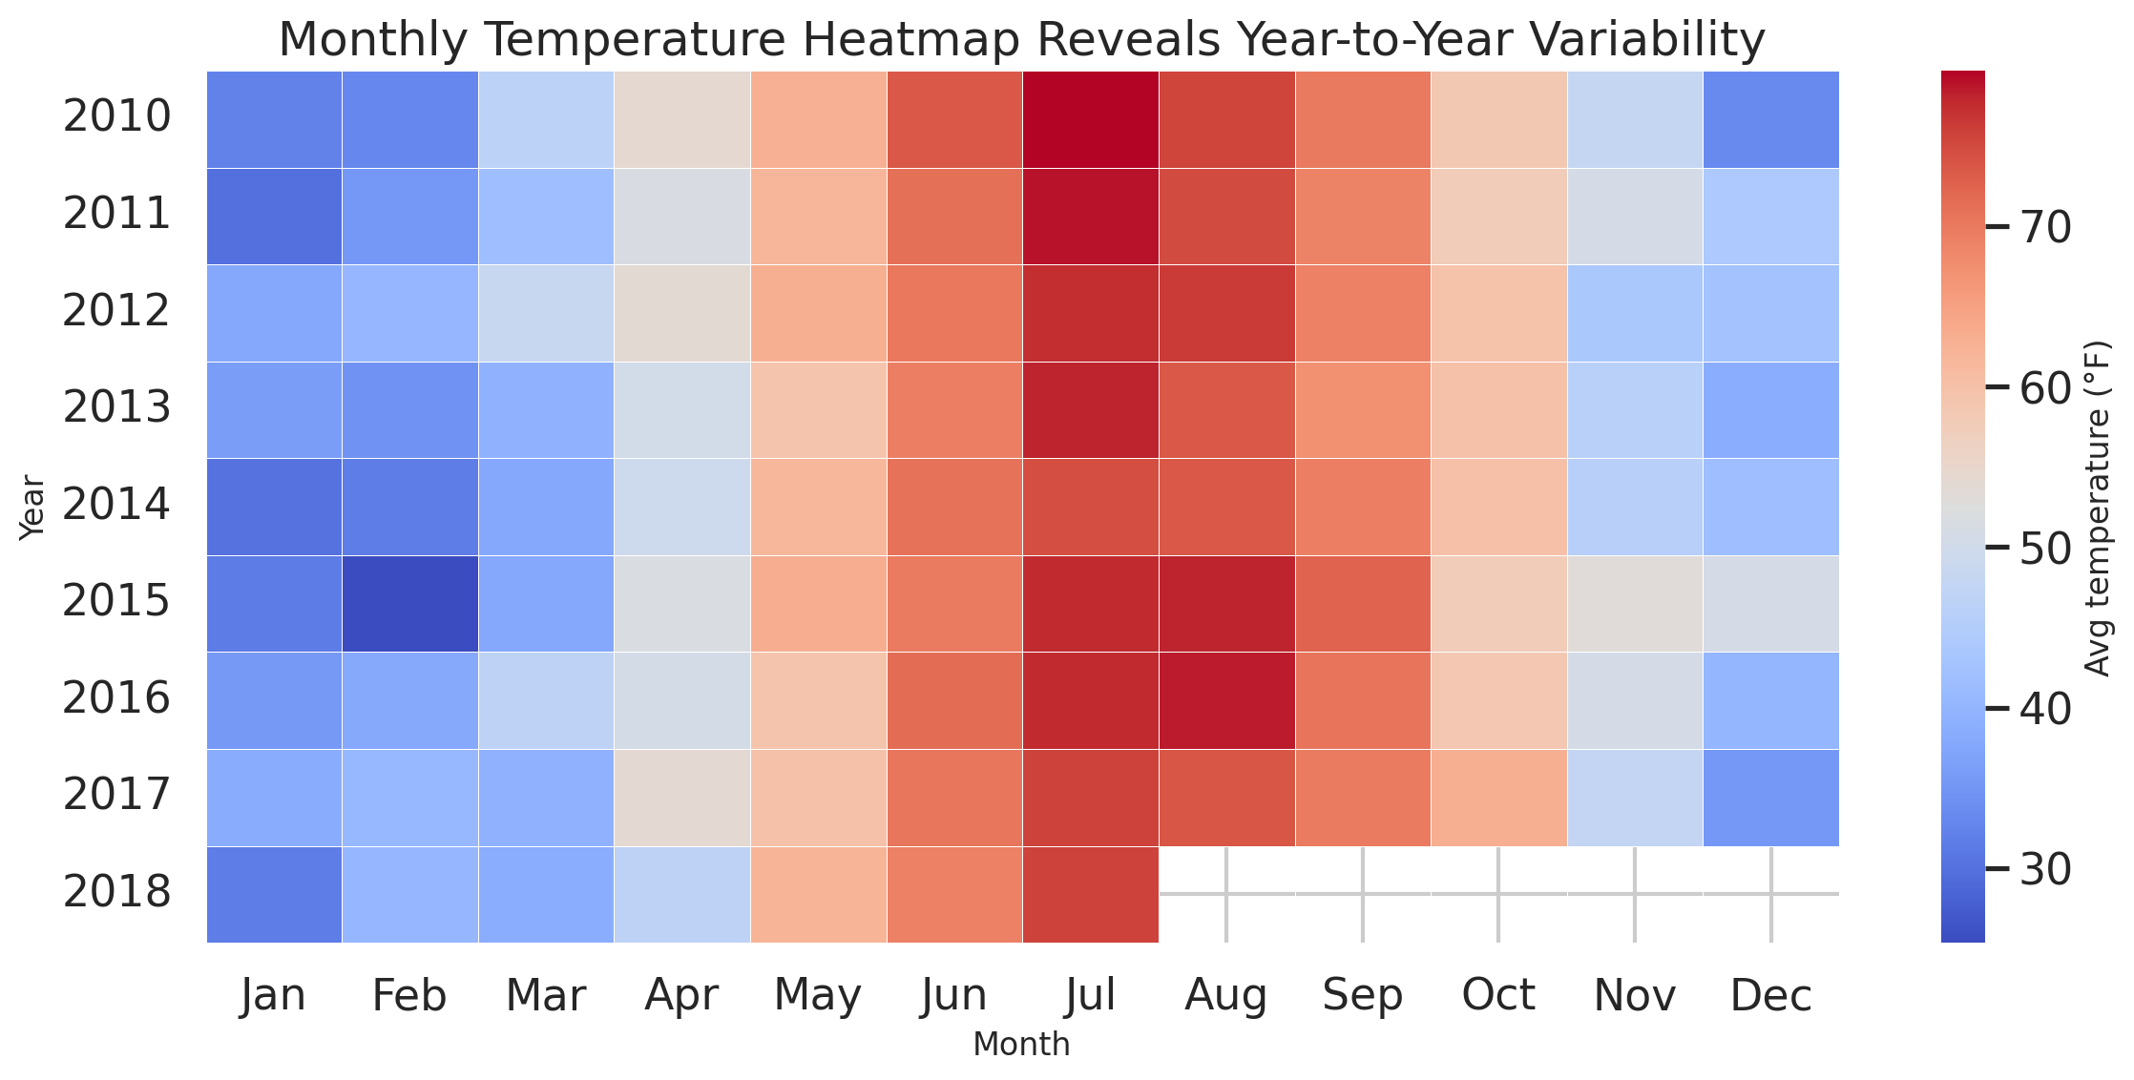
A heatmap highlights how monthly average temperatures change across years, making it easy to spot both the recurring seasonal pattern and year-to-year departures from that baseline.
Heatmaps are excellent storytelling tools when the audience needs to compare two time scales at once. Here, months show expected seasonality while rows allow quick scanning across years. The color structure makes unusually warm or cool months visible without requiring careful reading of many separate plots.
The strong horizontal pattern confirms that seasonality dominates the dataset, but color intensity shifts from year to year show that each season still carries its own variability. This is useful for framing resilience planning: averages are reliable, but individual seasons are not identical.

Figure 3. Annual precipitation and wet-hour share
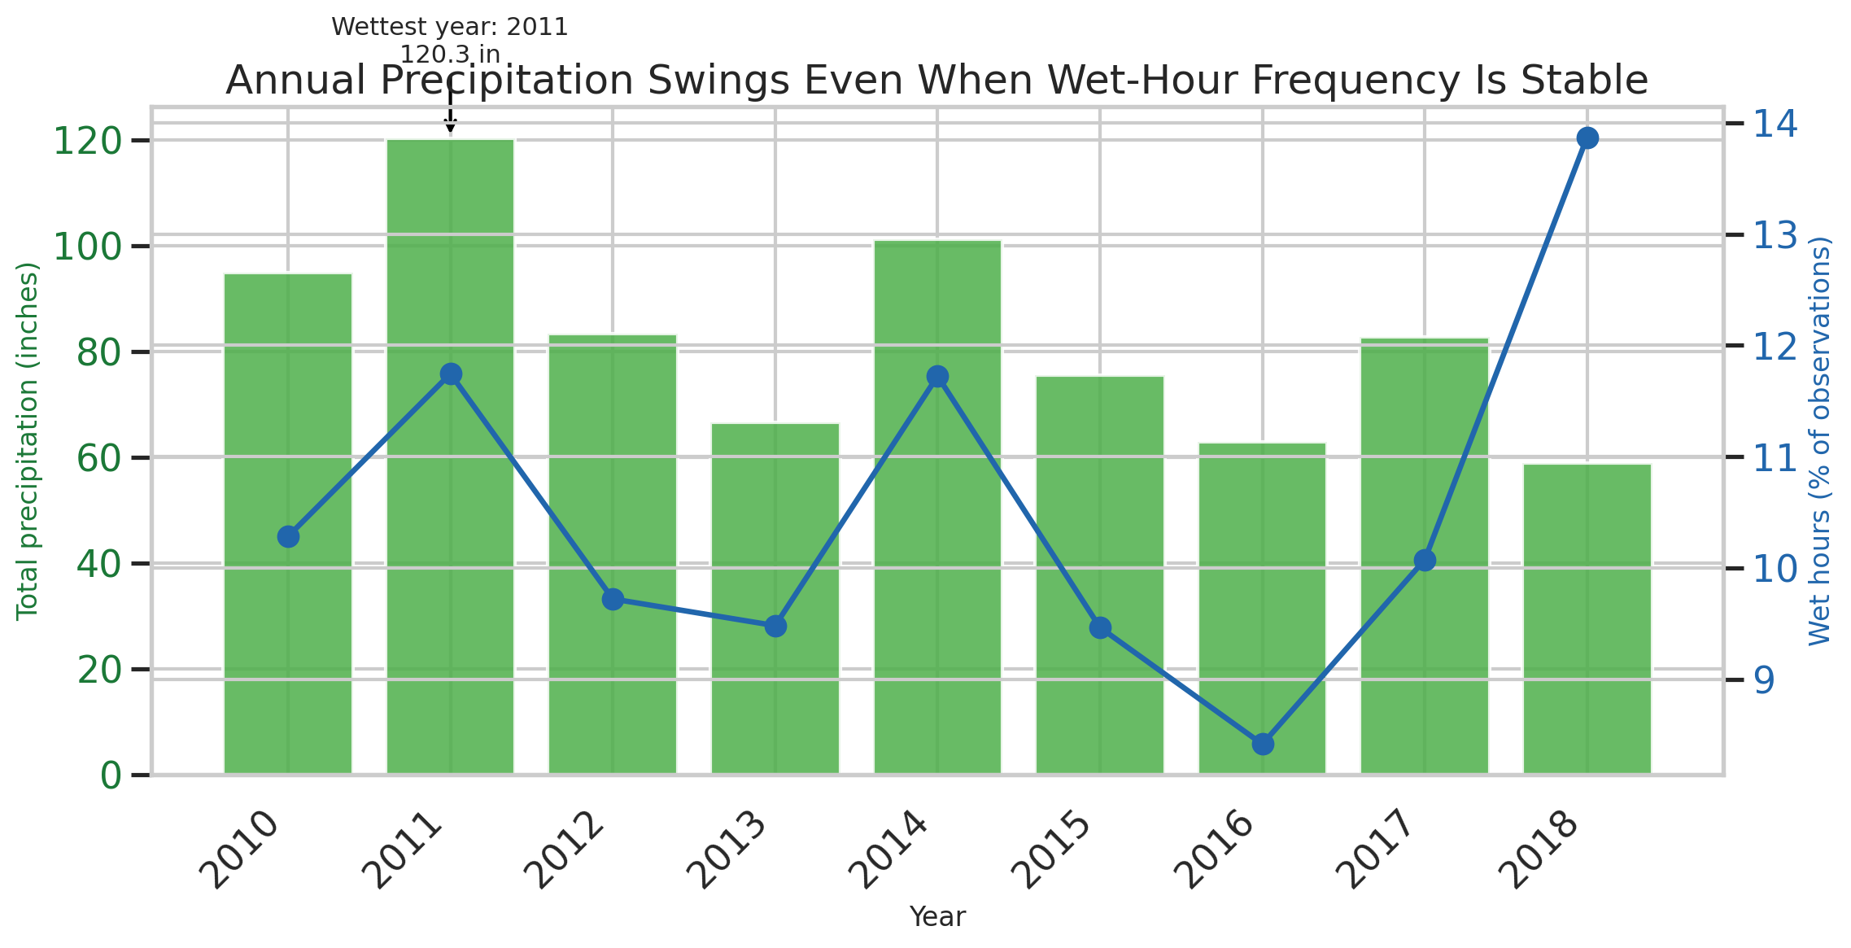
Bars show total yearly precipitation while the line shows the percentage of observations with measurable precipitation, separating how often it rains from how much water actually falls.
A dual-axis chart helps non-technical readers distinguish frequency from intensity. Two years can have similar numbers of wet hours but very different total precipitation if storms are stronger. That distinction is critical in operations, because infrastructure strain usually depends more on intensity and accumulation than on event count alone.
The wettest year in the record is 2011 with roughly 120.3 inches of precipitation, while the driest year is 2018 with about 59.0 inches. This spread indicates that annual water burden varies materially even within a relatively short historical window.

Figure 4. Humidity versus visibility density plot
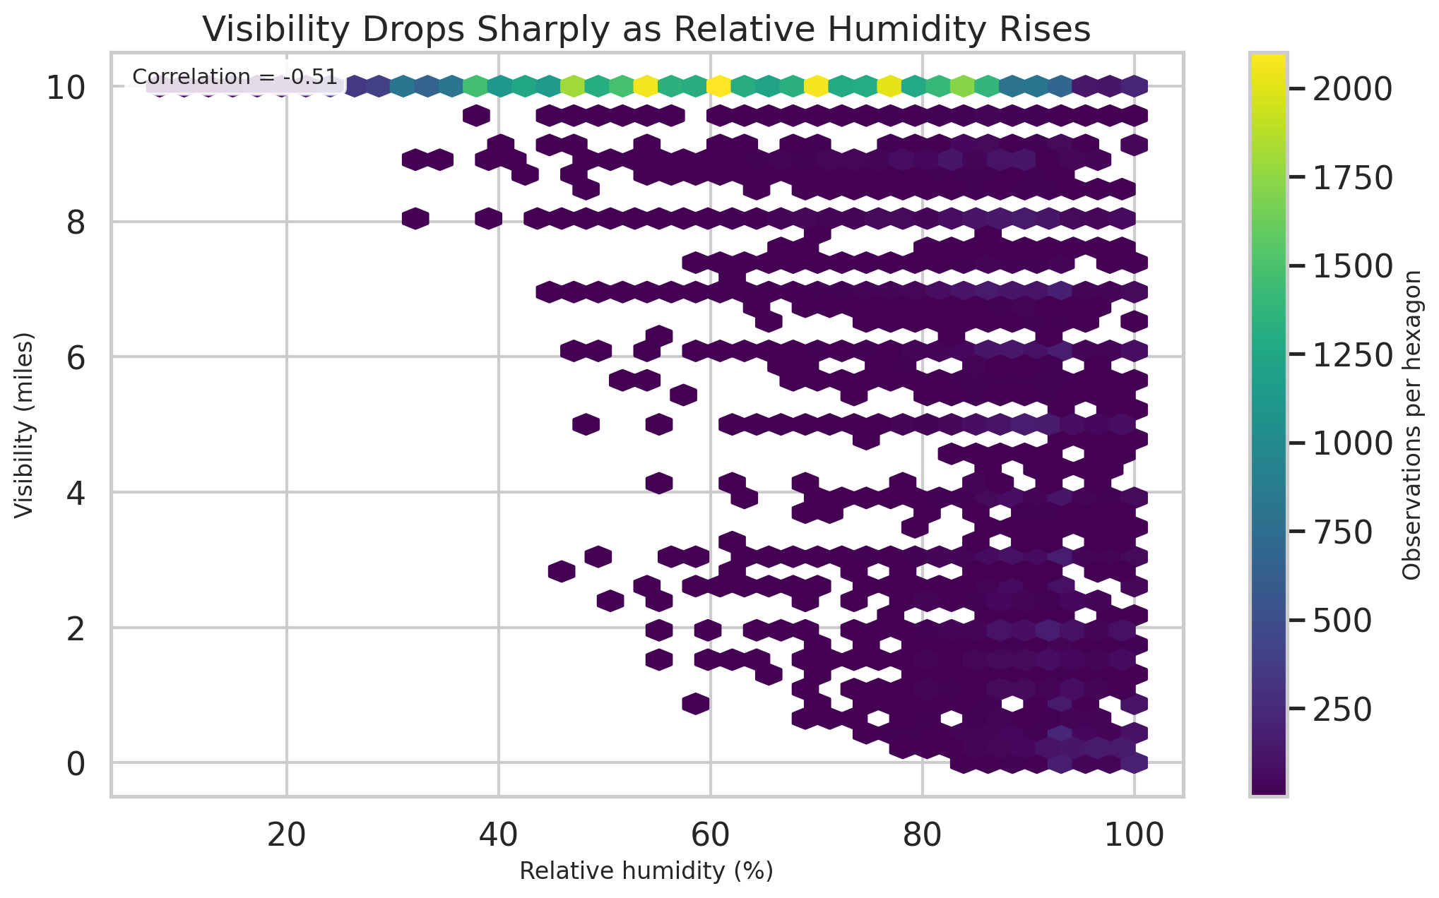
A hexbin plot shows where observations are concentrated and makes the relationship between moisture and visibility easier to see than a standard scatterplot would.
The dataset contains too many points for a simple scatterplot to stay readable. Hexagonal binning summarizes density while preserving the relationship structure. This allows the report to tell a practical story: when the air becomes saturated, visibility becomes more unreliable, which directly matters for airport and roadway decision-making.
The correlation between relative humidity and visibility is -0.51, indicating a clear negative relationship. In plain terms, more moisture in the air is generally associated with lower visibility and a higher chance of operational disruption.

Figure 5. Seasonal wind-speed distribution
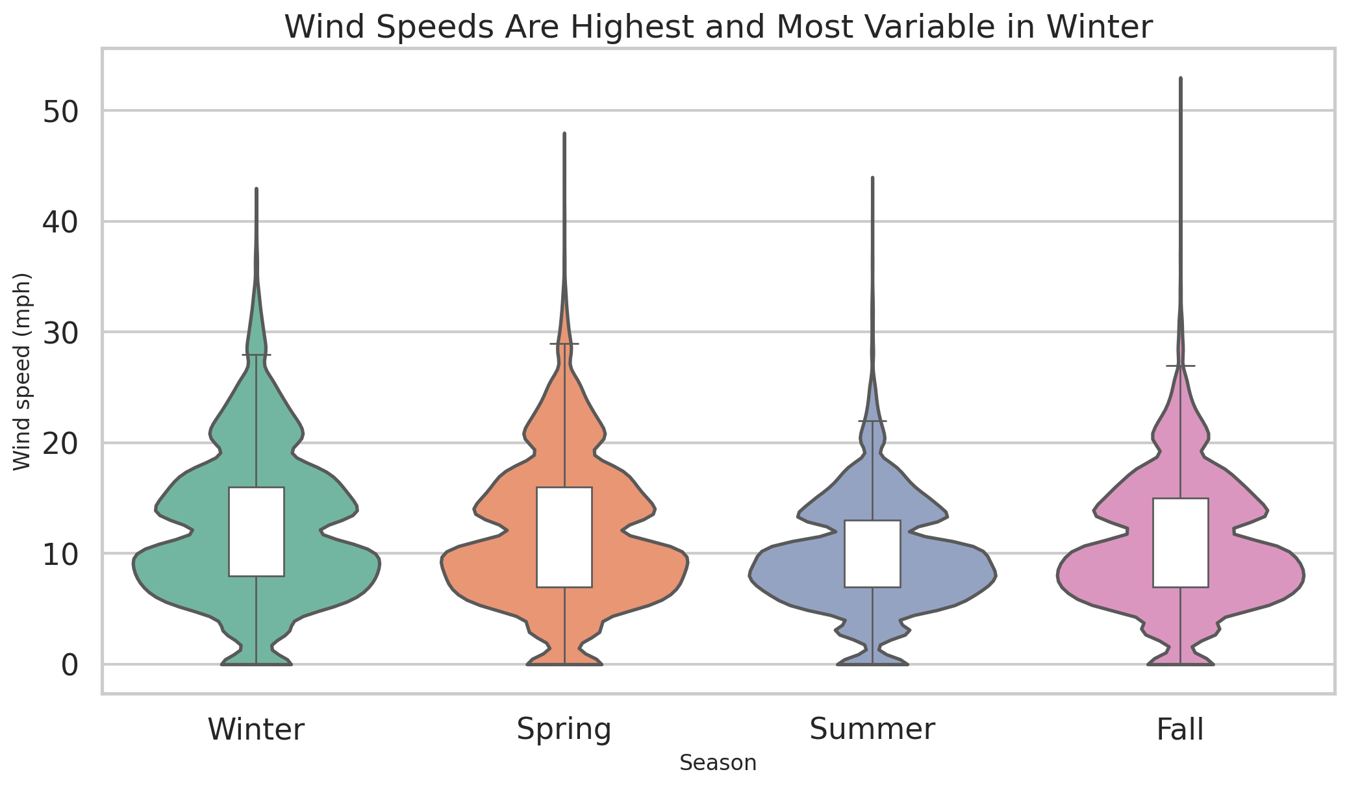
Violin and box overlays compare the full spread of wind speeds across seasons rather than showing only averages.
Average wind speed alone can hide operational risk. Distribution-focused charts communicate both typical values and variability, which is more relevant when considering gust exposure, runway operations, and maintenance scheduling. The violin shape helps a non-technical audience see that some seasons are consistently calm while others are more volatile.
Winter is the windiest season on average, and its distribution is visibly broader than the others. That combination suggests a larger planning burden because both stronger and less predictable winds are more common.

Figure 6. Wind rose of prevailing directions
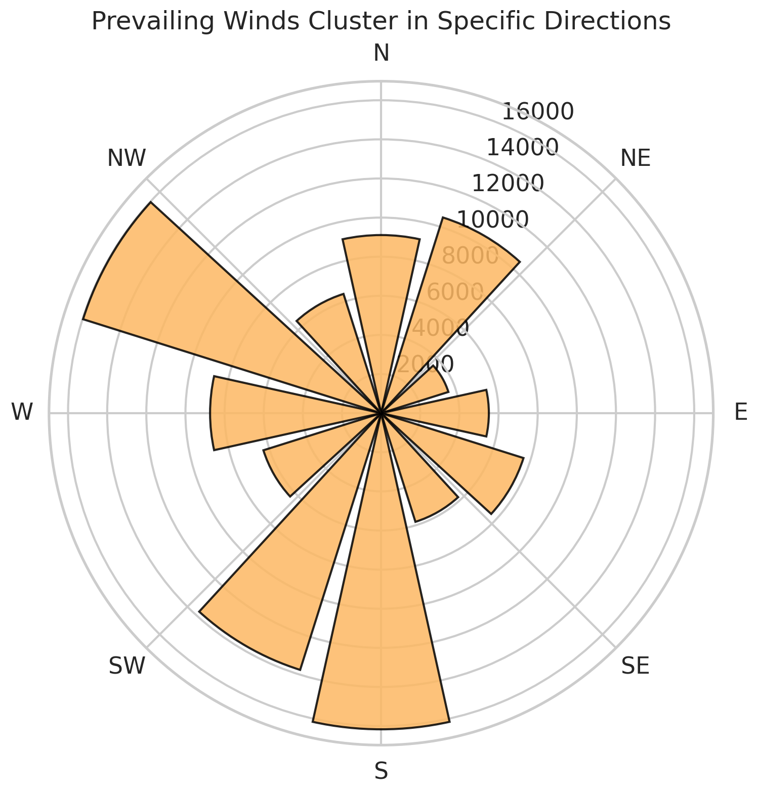
The wind rose converts directional data into a circular frequency display, making dominant wind corridors easy to recognize at a glance.
Directional weather data is difficult to communicate in a table. A wind rose turns abstract trigonometric encodings into a visually intuitive pattern. For airport storytelling in particular, this matters because wind direction affects runway orientation, sequencing efficiency, and crosswind management.
The directional clusters show that winds do not arrive uniformly from every direction. Instead, specific corridors dominate, which is valuable for communicating why orientation-sensitive operations must prepare for recurring patterns rather than random wind behavior.

4. Summary of Insights
- JFK weather is strongly seasonal, with the warmest typical month in Jul and the coolest in Jan.
- Annual precipitation varies substantially across the record, peaking in 2011 and bottoming out in 2018.
- High humidity is systematically associated with lower visibility (correlation -0.51), which is a meaningful operational signal.
- Winter stands out as the most wind-exposed season, with both higher central tendency and wider variability.
- The single wettest day in the record delivered approximately 14.95 inches of precipitation on 2011-08-14.

5. Potential Business and Scientific Implications
For airport and transportation operations, the results suggest that weather risk should be communicated in layers. Temperature seasonality is predictable and useful for long-horizon staffing or equipment planning, but precipitation totals and wind variability introduce year-specific uncertainty that affects runway use, de-icing demand, ground delay risk, and passenger flow management.
For public safety and infrastructure teams, the humidity-visibility relationship is especially actionable. Moist air, fog-prone conditions, or precipitation-linked visibility loss can be incorporated into early-warning systems for roadway advisories, airport dispatch, and maintenance planning.
From a scientific perspective, the report demonstrates how multiple atmospheric measurements tell a richer story together than any single variable alone. The combination of temperature, moisture, precipitation, visibility, and wind highlights the value of multivariate weather monitoring when studying local climate dynamics and operational resilience.

6. Conclusion
This assignment shows that advanced visualization is not only about aesthetic quality; it is about choosing chart forms that make complex evidence easier to understand. Using six complementary visuals, the report turns an airport weather archive into a coherent story about seasonality, water burden, visibility risk, and wind behavior. The resulting narrative is appropriate for non-technical stakeholders because each figure is both interpretable on its own and connected to a larger practical message.

Appendix: Reproducibility Notes
Python libraries used: pandas, NumPy, Matplotlib, Seaborn, and python-docx. The report was generated directly from the provided cleaned CSV file, with the notebook serving as contextual evidence for the data-cleaning lineage and dataset description.

